Objective Questions

Q1: What is the total no. of tables present in the data?
Ans. 1
Q2: What is the total no. of attributes present in the data?
Ans. 35
Q3: The data consists of some inconsistent and missing values so ensure that the data used for further analysis is cleaned.
Answer: Multiple columns contained missing values. I have followed below steps in cleaning the data:
- Remove Duplicates and found data doesn’t have duplicate value.
- chatStatus; it contained empty values. I filled the empty values with “call” as all the empty cells referred to the call.
- I extracted the Day, Year, and Month from column “createdAT” using formulas of Year, Month, Day,
- I also extracted hour from the “createdAt” using hours formula.

Q4: What is the change in daily call volume day by day and also find the average daily call volume.
Ans.
consultationType | Call
Row Labels | Count of CallSid |  | Change in calls volume
01-Jan | 115 | 115 | 81
02-Jan | 196 | 196 | -89
03-Jan | 107 | 107 | 265
01-Dec | 372 | 372 | -39
02-Dec | 333 | 333 | 50
03-Dec | 383 | 383 | -19
04-Dec | 364 | 364 | -111
05-Dec | 253 | 253 | 1
06-Dec | 254 | 254 | 0
07-Dec | 254 | 254 | -116
08-Dec | 138 | 138 | 150
09-Dec | 288 | 288 | 142
10-Dec | 430 | 430 | -6
11-Dec | 424 | 424 | -66
12-Dec | 358 | 358 | -10
13-Dec | 348 | 348 | -122
14-Dec | 226 | 226 | 50
15-Dec | 276 | 276 | -18
16-Dec | 258 | 258 | -73
17-Dec | 185 | 185 | 48
18-Dec | 233 | 233 | -24
19-Dec | 209 | 209 | -31
20-Dec | 178 | 178 | -19
21-Dec | 159 | 159 | 4
22-Dec | 163 | 163 | 78
23-Dec | 241 | 241 | -9
24-Dec | 232 | 232 | 26
25-Dec | 258 | 258 | -3
26-Dec | 255 | 255 | -13
27-Dec | 242 | 242 | -61
28-Dec | 181 | 181 | 77
29-Dec | 258 | 258 | -79
30-Dec | 179 | 179 | -21
31-Dec | 158 | 158 | -158
Grand Total | 8508

Average
250.2353

Q5: Which months experienced the highest and lowest call volumes?
Ans. Highest – December
Lowest – January
Q6: What is total operational cost for that month?
Ans.
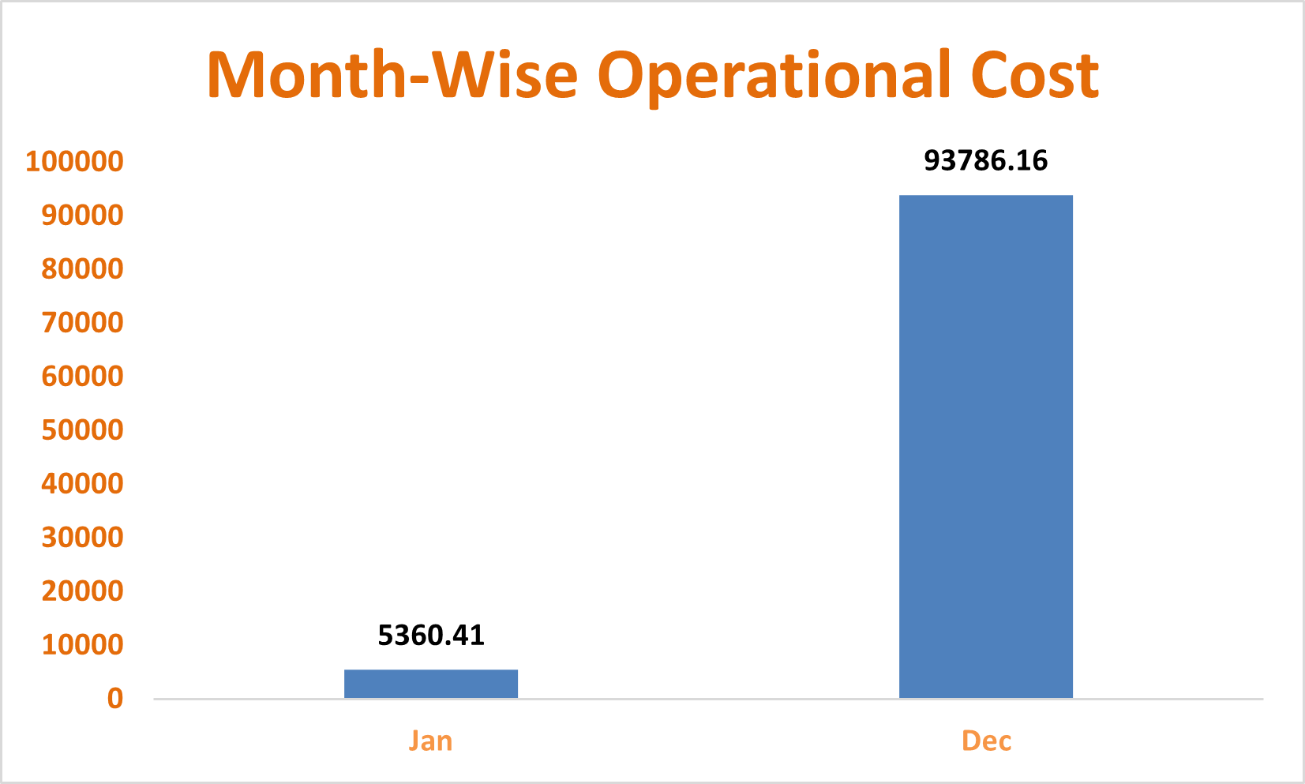
Q7: What is the average number of calls handled per agent per day?
Ans.
Total Calls | Total unique agents | Total days | Avg calls
8365 | 149 | 34 | 2

Q8: How many repeat callers are there, and what percentage of total calls do they represent?
Ans. 4735 Repeat callers are there that cover 50.60% of total calls.
Q9: What are the total sales generated by the call centre for each product category?
Call | 168520.62
Chat | 45494.68
Complementary | 0.00
public_live_Call | 50.60
Ans.

Q10: How many calls were made for each user ID and guru ID?
Ans. 8363 (I have prepared the pivot in excel sheet for both user id and guru id)
Q11: What is the correlation between call duration and customer satisfaction?
Ans. 0.055
Q12: Which guru has the highest and lowest customer satisfaction scores?
Ans.
Minimum |  | Maximum
Tarot Rittika | 0.00 | Astro Pujaa Rai | 7.50
 |  | Tarot Mystical | 7.50

Jan | 2.68
Dec | 2.95
Q13: What is average customer satisfaction score by month?
Ans.

Q14: How many categorical columns are there in the data?
Ans. 15

Subjective Question:
Q1: Should the investment be used to hire more agents, improve training programs, or upgrade call center technology?

As per the dataset presented Astrosage is an astrology based consultation call center. Therefore all the above mentioned points are equally important for the growth of organization but the most sustinable and significant option is going to be upgrading call center technology.

The above table shows the count of astrologers as per the total calls. Here for astrologer count we have used the COUNTA function along with the unique function. And total calls to get a ratio of calls per astrologer. As per the above data it is quite visible that hiring is not a very necessary need for the call center.

The Below Area chart shows the average rating of different Astrologers as per the given dataset which provides an important insight that the ratings vary with a very variable disturbance which implies a need of effective training to improve the quality of consultation resulting in improved ratings.

Average Rating for Each Guru:

Row Labels | Average of rating | Minimum |  | Maximum
Astro Pujaa Rai | 7.5 | Tarot Rittika | 0 | Astro Pujaa Rai | 7.5
Tarot Mystical | 7.5 |  |  | Tarot Mystical | 7.5
Daljit Kaur | 5.9
Astro Reema | 5.9
Tarot Ankita | 5.8
Astro Saraswat | 5.6
Tarot Diva Poonam | 5.5
Astro Trisha | 5.4
Tarot Oormika | 5.4
Astro Manish S | 5.0
Swami Chandreshwaranand��G | 5.0
Tarrot Ria | 5.0
Vandana Bhutani | 5.0
Tarot Srishti | 4.9
Tarot Rhea | 4.8
Aham T | 4.8
Astro Swami G | 4.7
Astro Niddhi Guptaa | 4.5
Astro Ruchi | 4.4
Astro Manish SM | 4.4
Gopi Vans | 4.3
Astro SavitriDevi | 4.3
Astro Himanshu | 4.2
Astro Dr Balkrisna | 4.2
Shalini Sharma | 4.2
Astro Ashok | 4.2
Astro Sukhdip | 4.1
Astro Lakshmi | 4.1
Tarot Esha | 4.1
Tarot Vedika | 4.0
Tarot Anshu | 4.0
Tarot Priyal | 4.0
Tarot Monika | 4.0
Acharya Arti S | 4.0
Astro Pulkit S | 4.0
Tarot Priya S | 3.9
Astro preeti | 3.9
Astro Jha Guruji | 3.9
Tarot Meera | 3.9
Tarot Ari | 3.9
Astro Smarti M | 3.8
Tarot Yashita | 3.8
Astro Sonam S | 3.7
Astro Aditya N | 3.7
Tarot Chanchal | 3.7
Astro Savita S | 3.7
Tarot Bibhuti | 3.7
Astro Meena | 3.7
Tarot Gurpreet Kaur | 3.7
Tarot Rupanshi | 3.6
Tarot Harleen | 3.6
Astro Dr Shrey | 3.6
Astro Aishwarya | 3.6
Tarot Rachana | 3.5
Tarot Daljit | 3.5
Astro Rhea | 3.5
Tarot Mamta D | 3.5
Astro Aabhishek | 3.5
Tarot Shakti | 3.5
Astro Divya | 3.5
Tarot Surbi | 3.5
Dr. Shrey | 3.5
Astro Prashant | 3.4
Acharya Shastri | 3.4
Astro Shalini | 3.4
Astro Deepti | 3.4
Astro Seema | 3.4
Tarot Gauri | 3.4
Astro Shweta | 3.3
Astro Anju | 3.3
Tarot Chanchal singh | 3.3
Astro Krishaa | 3.3
Astro Nisha | 3.3
Manorma Singh | 3.2
Astro Mukesh | 3.2
Astro Aditya | 3.2
Tarot Aadhvik | 3.2
Tarot Gurpreet | 3.1
Astro Aditya Jhha | 3.1
Tarot Aritra C | 3.1
Tarot SampritaP | 3.1
Aachary Prateek | 3.1
Tarot Barbiie | 3.1
Dr. Balkrisna | 3.0
Astro Aacharya Dev | 3.0
Tarot preet | 3.0
Tarot Ria | 3.0
Astro Jha | 3.0
Tarot Shilpa P | 3.0
Tarot Kaashvi | 2.9
Astro Gurdeep | 2.9
Astro Sujata S | 2.9
Astro Anaya | 2.9
Astro Uma Kant | 2.9
Tarot Sunita | 2.9
Tarot Rupika | 2.8
Astro Ankita C | 2.8
Tarot Seema | 2.8
Astro Dr Harish | 2.8
Tarot Gargi | 2.8
Astro Akash | 2.8
Astro Sanjeev | 2.7
Tarot Akshay | 2.7
Astro Krishna | 2.7
Astro Vishwajeet | 2.7
Tarot Rushali | 2.6
Dr Balkrisna | 2.6
RAKESH KAUSHIK | 2.6
Astro Rajiv B | 2.6
Astro Sakthi | 2.5
Acharya Dev | 2.5
Tarot Muskaan | 2.5
Astro Neetu | 2.5
Dr. Pratibha | 2.5
Tarot Riya | 2.4
Himanshu Pandey | 2.4
Tarot Bee Riya | 2.4
Astro Yashi | 2.3
Astro Naksh | 2.2
Tarot Pooja | 2.2
Usha Siingh | 2.2
Tarot Leena | 2.1
Kaveshii Chauhaan | 2.0
Tarot Raghavi | 1.9
Astro Brejesh | 1.9
Tarot Neha R | 1.9
Tarot Swati | 1.9
Astro Dr Ravindra | 1.8
Astro Mahesh S | 1.8
Super Guru Ji | 1.8
Astro Rajesh S | 1.8
Tarot Nipamani | 1.7
Astro sree valli | 1.6
Astro Anil Shukla | 1.6
Astro Rohan S | 1.5
Astro R J S | 1.5
Tarot Supriya Suri | 1.5
gurucool support | 1.4
Dr. Harish | 1.3
Tarot Keshmin | 1.2
Tarot Ittishri | 1.2
Astro Yogendra | 1.0
astro chandan | 1.0
Tarot Punam | 0.9
Astro Sushil S | 0.9
Astro Aditya | 0.8
Acharya Divyansh | 0.4
Astro K Ojha | 0.1
Tarot Rittika | 0.0
Grand Total | 2.9

The above Pie chart shows the call status distribution as per the chart there is a need for the technological update to increase the completed calls rate. Hence there is a need for a Technological update to increase the customer satisfaction.
Q2: What are the potential risks of each investment option (hiring, training, technology upgrades), and how can they be mitigated?

Hiring –:
Hiring new astrologers is one of the most difficult tasks of the all because it is a long term process. The recruitment team needs to take care of the fact that the candidate is worthy enough for the role . A proper training guide is needed for the person and if the candidate backs out last moment then all the resources are wasted and they need to start from ground zero. Moreover using the Pivot tables and visualization functionality in spreadsheets it is quite visible that there are enough consultants to manage the call.

Mitigation-:
The problem can be mitigated with the referral bonuses to the outperforming consultants to hire new consultants that will not only help in hiring but also increasing the quality of the consultants in call center.

Training –:
Training the employees for a better a consultation and customer satisfaction is very important to improve the customer satisfaction. But there some potential risks as well because implementing a new training suite will involve availability of all the consultants at once as well as new training suite will require new strategies. This can be a heavy investment and tedious for the organization.

Mitigation-:
The problem can be mitigated with a very limited investment by organizing guest workshops and rewarding programs to the best rated consultation of the week and sharing of the recording of that particular consultation among the Astrologers.

Technological update
Technological updates are one of the most important updates for the effective and continuous customer satisfaction as it is the most crucial factor for good user experience.
It also involves some risks i.e. an lot of investment , a technical support staff , risk of technical failures and most importantly compatibility of astrologers with new technical updates.

Mitigation-:
The problem can be mitigated with the new CRM for better customer support and satisfaction. And including a new workforce environment can help in easier and better compatibility with the technology.

Q3: How does AstroSage's call center performance compare to AstroGuru's average call volume, customer satisfaction, and agent performance?
Will you use any aggregation function or a visualization here to solve the problem?
Ans.
For comparison of AstroSage and AstroGuru we don’t have any dataset of AstroGuru . Hypothetically if it was available we can easily perform the analysis by
- Using pivot tables, we can find the total calls and average calls and compare.
- We can make a pivot chart for user wise rating and astrologer wise rating compare it for both the call centres.
- For agent performance we can make a bar chart of calls handled vs Astrologer Name.
Also, can make a Pivot Chart for Top performers of Both the call centres and compare them.
Q4: How can the call centre improve its handling of peak call periods to ensure high customer satisfaction?
Mention the functionality you will use for giving the suggestions, will it be any aggregated function or a visualization?
As visible from the above chart we have a very variable flow of peak hours so the company can communicate with consultants and make an effective workflow by monitoring the availability of them and make batches, for different hours of the day and allow the customer to choose among the available one's. Moreover, restrict each consultant on defined number of sessions only.

Here we can clearly see from the graph where vertical axis represents the peak hours and horizontal axis represents the total calls.

1. Extreme Concentration and Peak Hour
- Insight: The single heaviest call hour is 08:00, with 660 calls. This is the absolute priority bottleneck. The hours of 07:00, 08:00, 09:00, 11:00, and 12:00 all exceed 479 calls.
- Implication: If the call center doesn't have an effective staffing strategy specifically for 08:00, the resulting backlog will negatively impact the quality of service for the subsequent hours (09:00, 10:00, 11:00) as agents struggle to catch up.

2. Primary Peak Window (The Morning Rush)
- Insight: The main peak window runs from 07:00 (551 calls) through 12:00 (479 calls). This six-hour period represents the majority of the day's total call volume and is when most customers are starting their workday and making calls.
- Implication: Staffing must be highest and most robust during this window. Staffing models like the Erlang C formula must be applied using these high call volumes as the input.

3. Secondary Peak and Afternoon Demand
- Insight: There is a noticeable secondary spike at 17:00 (374 calls).
- Implication: This suggests a second wave of customers calling after they leave work. Staffing cannot drop off too steeply in the late afternoon; relief or second-shift agents must be scheduled to cover this demand.

4. Low-Volume Window (Nights/Early Morning)
- Insight: The lowest volume occurs between 00:00 (52 calls) and 06:00 (449 calls). Demand is extremely low from 00:00 to 03:00.
- Implication: This time can be covered by a minimal skeleton crew or specialized night-shift agents. This window is ideal for system maintenance, training, and mandatory time off-phone.

5. Variable Flow (The Challenge)
- Insight: The flow is highly variable, dropping from 660 (08:00) to 52 (00:00).
- Implication: A rigid, 9-to-5 staffing model is completely inadequate. The center requires flexible scheduling, staggered shifts, and potentially part-time staff to meet the fluctuating demand curve precisely

Q5: Based on historical data, what strategic initiatives should be prioritized to improve efficiency and customer satisfaction?

Ans.

Row Labels | Average of rating
Call | 3.5
Chat | 2.7
Complementary | 4.5
public_live_Call | 3.0
Grand Total | 2.9

Based on the above visualisation i.e.
- Call status Distribution
- Consultation Wise Ratings
- Peak hours as per calls received
The call centre can adopt following strategies
Optimizing operational Efficiency -: The call centre can focus on allocating uniform number of calls to all the astrologers on a daily basis. They can do batching of a particular number of consultants and let the customer choose the consultant through a pre booking and remove them as soon as they get selected for a threshold value (Like 10 calls a day). As per the availability of consultants.
Improving Customer satisfaction -:
- Technological update is a must to increase the quality of consultation so that the call completion ratio could be increased at least up to 60% which is currently at 23%. For a good customer review properly consulting and completing the call is very important. The call centre can optimize the Dashboard as well as the App for better user experience more customer retention. Moreover, it’s important to have a backup consultant in case the assigned consultant cannot continue with call. Also, the organization should provide a free/discounted session if it gets cancelled or the consultant is not available.
- They should focus on streamlining the chat process through chatbots for general queries based on the past records also AI can be used as well for better and fast customer service.
- CRM software must be used to assign a consultant to customer for all the queries giving a familiar experience just as happens with a patient having a constant Family doctor. This will help as the Consultant would be having all details of customer from mentality to Behaviour. This will result in complete resolution of queries from customer.

Q6: What can be the key factors contributing to high customer satisfaction scores, and how can these be leveraged to improve overall performance?
What is the basis for the suggestions? And mention how you decided if the satisfaction score affects the ratings.
Ans.
Row Labels | Average of rating
Call | 3.5
Chat | 2.7
Complementary | 4.5
public_live_Call | 3.0
Grand Total | 2.9

consultationType | (All)
Row Labels | Average of astrologerOnCallDuration
0 | 0.0
1 | 0.0
2 | 64.1
3 | 58.6
4 | 124.3
5 | 127.4
6 | 0.0
7 | 0.0
8 | 0.0

Row Labels | Average of userOnCallDuration
0 | 0.0
1 | 0.0
2 | 59.2
3 | 53.8
4 | 114.9
5 | 117.7
6 | 0.0
7 | 0.0
8 | 0.0

The consultation type, Astrologer on call duration are the key factors for customer satisfaction. As we can see from above pivot tables the chat customers are more satisfied, whereas call customers with a higher call duration have provided higher rating. So the call centre should focus on complete customer query resolution, if general then through chat otherwise a detailed call session it could result even better it is a video session that could be pre booked.
Q7: How should the call centre balance the workload among agents to ensure optimal performance and avoid burnout?
Mention your approach and spreadsheet function for the answer.
The call centre must try and use all the consultants equally to manage the workload by assigning them equal number of calls by assigning calls to them as per the availability, moreover they can also focus on pre-booking model and use effective UI to give users an option to select the consultants to provide better user experience, equalising workload by removing the consultant as soon as they are chosen for a threshold count of bookings.
As shown in the below chart there is an uneven distribution of calls among the consultants.
The Top 10 consultants cover 44% of total calls.

Three Simple Solutions for Peak Hours

A. Fix Scheduling (Making Batches)
- What to do: Get consultants to work when demand is highest. Use the identified peak hours to create special shifts or "batches" (like 6 AM to 10 AM) where more consultants are required.
- The easy benefit: This guarantees someone is available when the customer calls, instantly reducing "busy" and "no-answer" failures.

B. Balance the Workload (Setting Session Limits)
- What to do: Stop overloading the best consultants. Use dynamic routing to send new calls to the least-busy available consultant. You can also put a soft limit (or "defined number of sessions") on your top performers to prevent them from burning out and free up calls for others.
- The easy benefit: The workload is spread out, preventing your best people from getting exhausted and ensuring every customer has a chance to connect quickly.

C. Smart Customer Choice (Monitoring Availability)
- What to do: When a customer logs in, only show them consultants who are online and ready right now. Allow the customer to choose from this available list, but filter the list to also show their high average ratings (e.g., $4.9$ stars).
- The easy benefit: The customer feels in control, and they are much more likely to connect with a consultant who is ready to give a great, successful consultation.

Q8: What new technologies or tools could be implemented to enhance call center operations and customer service?
- Introduction to chatbots and Virtual assistants for regular queries can help in saving the consultants energy for complex queries and consultations.
- Use of AI for personalization based on some insights of customer for better user experience can result in repeat orders/consultations.
- Maintaining a CRM software about past consultations and customer details can help in future consultations and targeting old customers.
- Feedback mechanism should be adopted to make the customers happy and improve the quality.
- Personalized pre booked video sessions with consultants can help in the repeat customers as the interaction helps in understanding the customer behaviour.
- Developing apps with different notifications and games such as puzzles and making the customers learn about the birth charts and planets can attract new customers.

Q9: What metrics should be included in the final dashboard to comprehensively view call center performance and guide investment decisions?
1. website distribution: Shows which platforms (website, app, etc.) generate the most volume.
2. Revenue generated by category type: Tracks total net revenue and shows which consultation types (Call/Chat) are most profitable.
3. Call distribution over hrs: Identifies the variable Peak Hours (e.g., 6, 8, 9, 10, 14, 15, 16) where staffing is most critical.
4. Day by day call volume: Tracks weekly or monthly trends and identifies days with high/low call volume for long-term capacity planning.
5. Call status distribution: Shows the percentage of calls that were completed, failed, busy, or incomplete. This is the most critical metric for technology investment
6. Chat status distribution: Same as above, but for chats. Reveals platform or agent capacity issues specific to the chat channel.
7. Rating wise guru distribution: Shows the distribution of ratings received by each agent (e.g., how many 5s, 3s, and 1s).
8. Rating wise customer distribution: Shows the overall percentage of customers giving 5-star ratings vs. 1-star ratings.
9. Top 10 guru by Rating: Identifies the highest-performing agents (the "role models," like Astro Ruchi), whose practices should be formalized into training.

Q10: How would you allocate a 1 crore rupee investment to optimize operational efficiency, enhance customer satisfaction, and boost profitability, and what analysis-based recommendations would you offer to support this?
[you have to give bullet pointers to answer this question]
Ans.
- Astro-sage should focus upon Technological upgrades to bring customers to the app and dashboard more frequently and decrease the cancelled and failed consultations to improve the profitability.
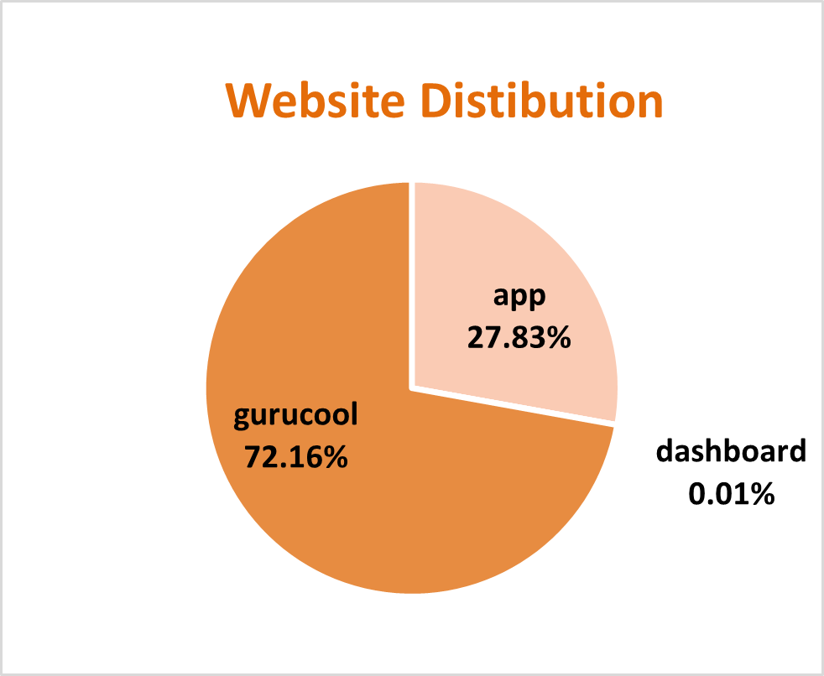
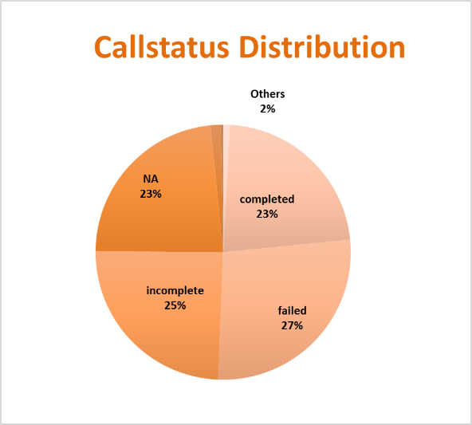
- Astro-sage should focus on call consultations to increase the revenue and installs some chatbots and virtual assistant for general chat process instead of consultants to have them available for the peak hours to reduce the operational cost.
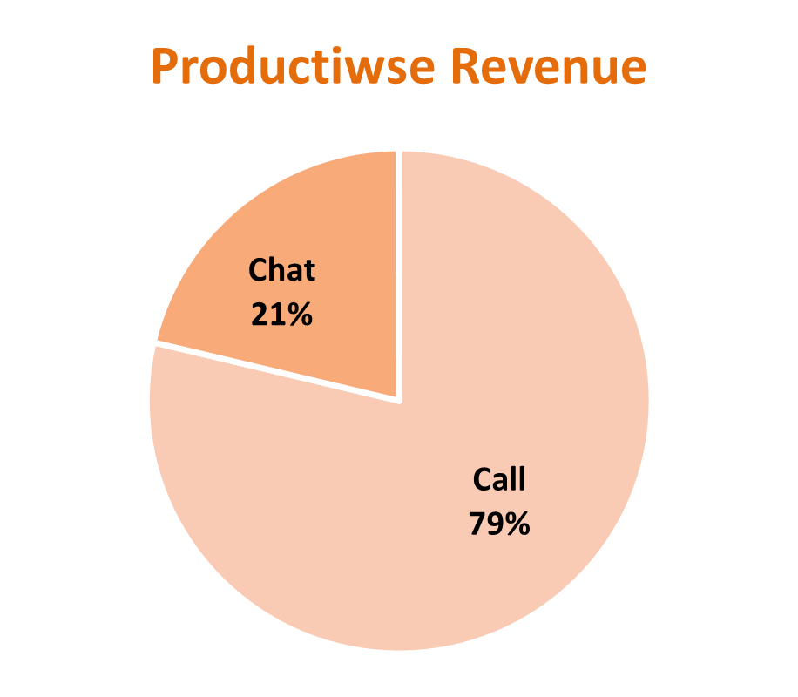
- Astro sage should focus upon the pre-booking model and include CRM Software to assign a particular client to a particular customer to increase customer satisfaction and reduce time lapse and repetitive procedure of intro sessions.
- Finally, Astro- sage must allow a customer to choose a consultant and take feedbacks of the session. And weekly distribute the most rated and most appreciated astrologer’s session recording to others and organize regular training to stay up to date and keep all the consultants on the same level , to maintain the quality and consistency of the session.
